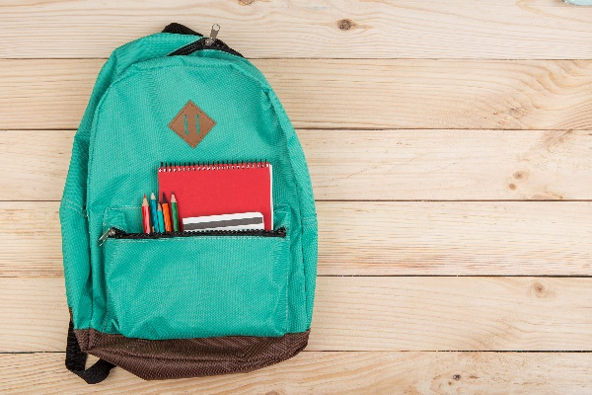

**4th Grade Supply List**

8 packs of pencils (school year)

EACH STUDENT NEEDS 2 spiral notebooks per class (6 total)

ONE INCH BINDER WITH POCKETS (MATH)

Scissors

Colored pencils (2 boxes)

Glue Sticks (3 packs)

Kleenex / Clorox Wipes / Hand Sanitizer

College Ruled Paper (5 packs) (school year)

Personal Ear Buds

Erasers

(4) 3-prong pocket folders